List of Model Photos for Viewing:

RESPIRATORY SYSTEM :

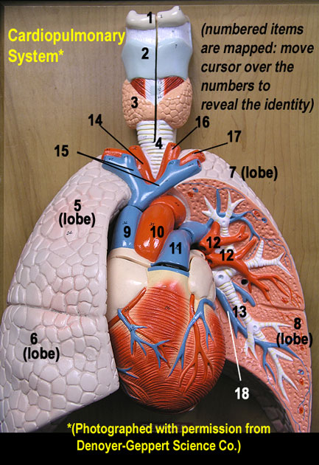 Cardiopulmonary Systems (anterior view)

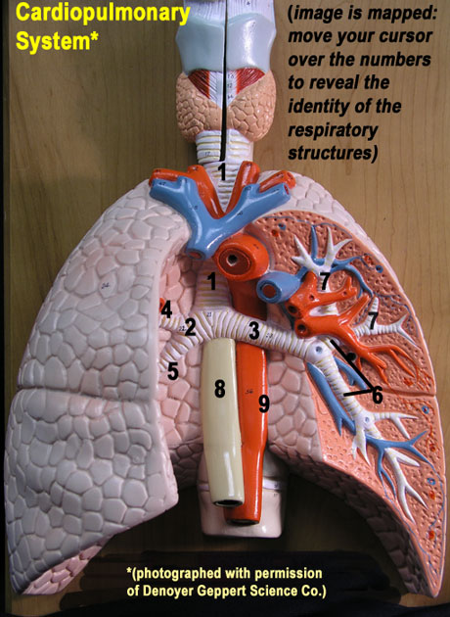 Respiratory System (anterior view)

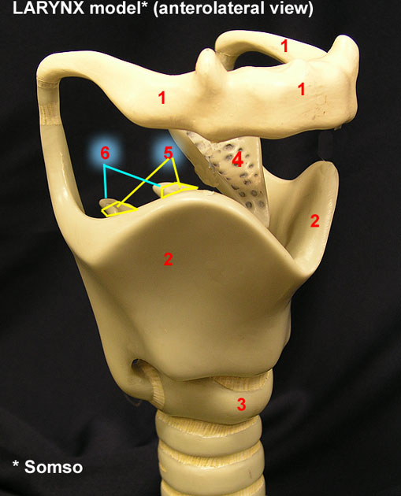 Larynx model (antero-lateral view)

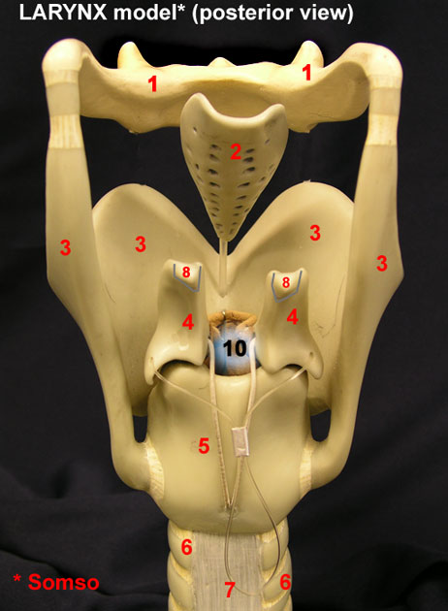 Larynx model (posterior view)

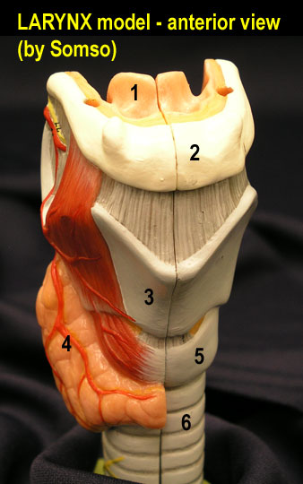 Larynx model (anterior view)

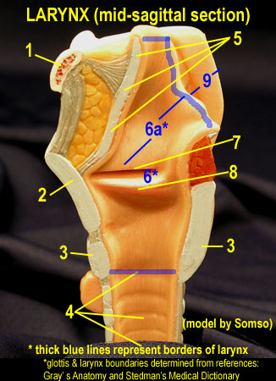 Larynx model (midsagittal view)

CARDIOVASCULAR SYSTEM:

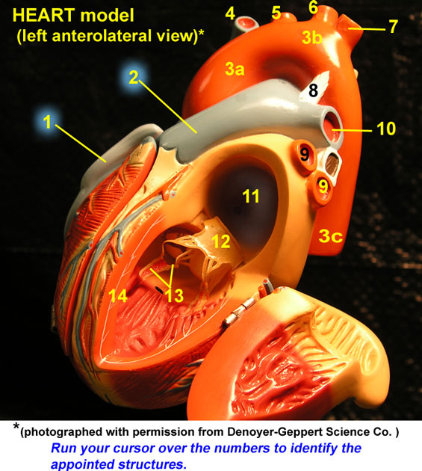 Heart Model- dissected (left antero-lateral view)

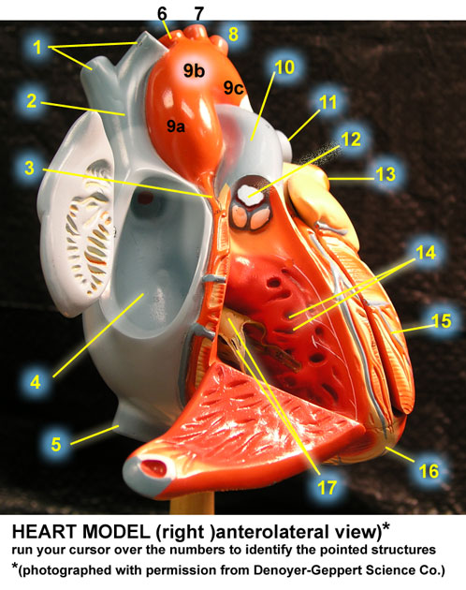 Heart Model – dissected (right antero-lateral view)

