DIGESTIVE SYSTEM

List of models for viewing:

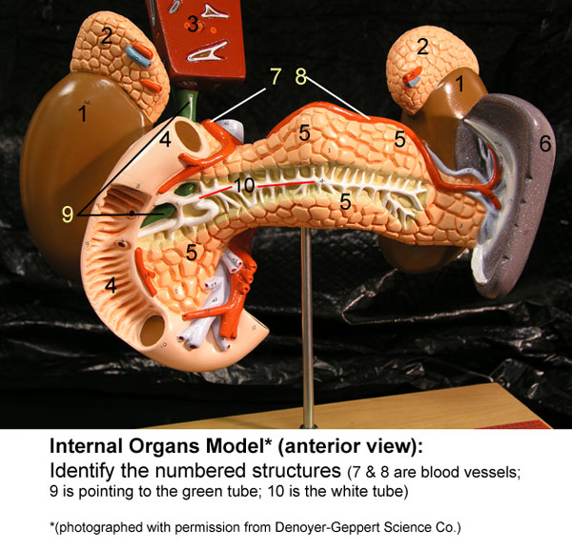 Internal organs model (anterior view). Numbered structures are mapped; just move your cursor over the structure or number to identify the appointed item.

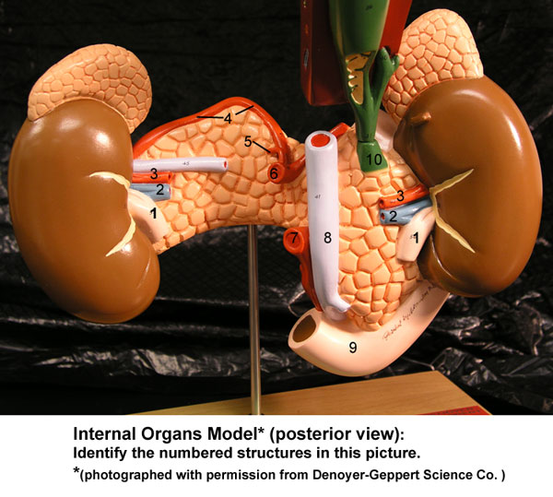 Internal organs model (posterior view); numbered structures + are mapped

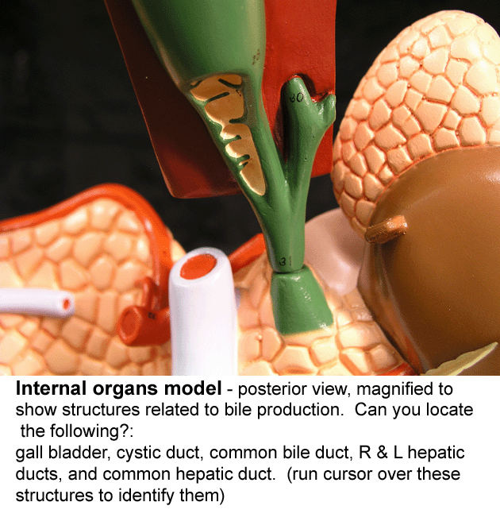 Internal organs model: Close-up of the ducts & structures associated with bile production. Although there are no numbers added to the image, it is mapped. Move and hold your cursor over an area or structure to check its identity.

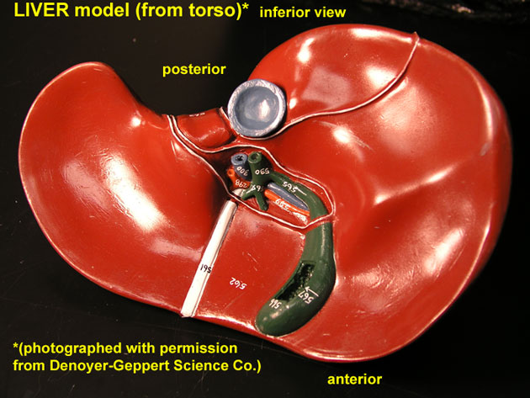 Liver – inferior view (from Torso model).
Although there are no numbers added to the image, it is mapped. Move and hold your cursor over an area or structure to check its identity.

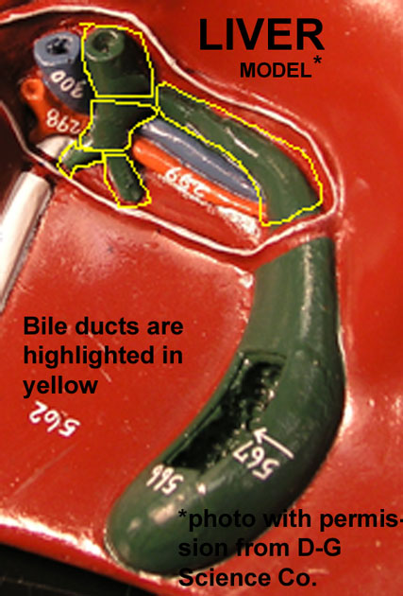 Magnified view of structures associated with bile production (inferior view of liver from the Torso model). Blood vessels and structures associated with bile production/storage are mapped on this image.

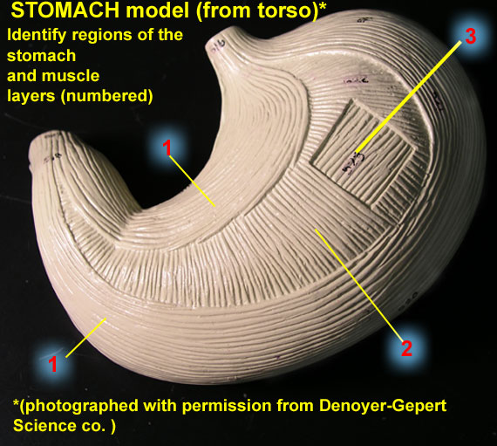 Stomach (from Torso model) external view. Layers of stomach are numbered, while regions of stomach are not. To check the identity of the regions, move & hold your cursor over an area of the stomach.

