UROGENITAL SYSTEM

List of Models for Viewing:

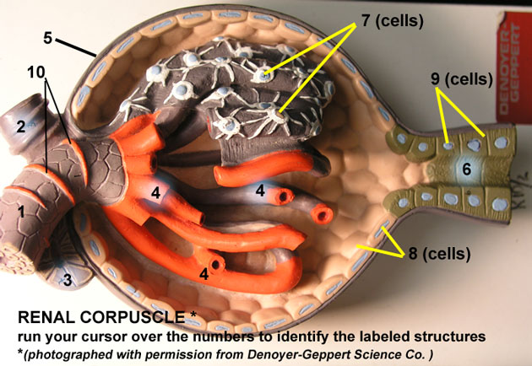

Vascular and tubular components of NEPHRON

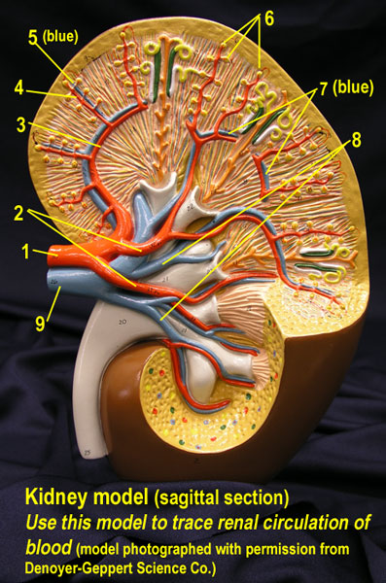 Blood vessels of the Kidney

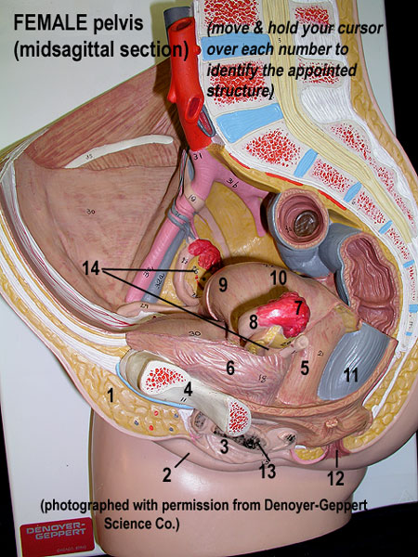 Female Pelvis (reproductive) midsagittal section

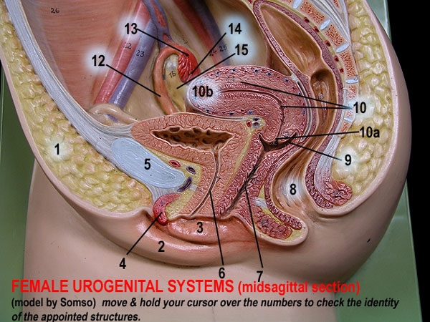 Female pelvis II (reproductive) midsagittal sec.

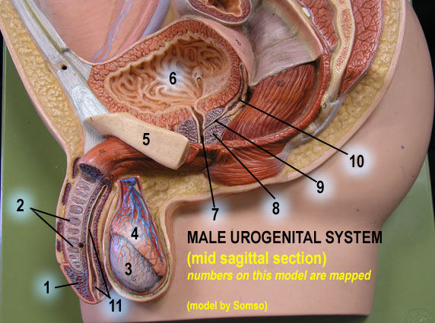 Male pelvis (reproductive structures)

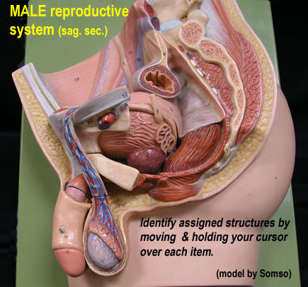 Male pelvis II (reproductive structures)

